OPL2500

ULTRA-LOW POWER 2.4GHZ WI-FI + BLESMART SOC

Opulinks Wireless Utilities User Guide

|  |  |  |  |  |  |  |  |  |  |  |  |  |  |
| --- | --- | --- | --- | --- | --- | --- | --- | --- | --- | --- | --- | --- | --- |
|  | OPULINKS   |  |  |  | | --- | --- | --- | |  |  |  | |  |  |  | | http://www.opulinks.com/ | Copyright © 2017-2022 Opulinks. All Rights Reserved. | | |  |  |  |   OPL2500-Opulinks-Wireless-Utilities-user-guide_UGEN-104 ⎜ Version 1.0 |

|  |  |  |
| --- | --- | --- |
| Date | Version | Contents Updated |
| 2022-12-14 | 1.0 | * Initial Release |

TABLE OF CONTENTS

1. Introduction 1

1.1. Application Scope 1

1.2. Abbreviations 1

2. Software and Hardware configuration 2

2.1. Hardware and Software Preparation 2

2.2. Install APP 2

2.2.1. Install Android APP 2

2.2.2. Install iOS APP 3

3. OWU interface 5

3.1. OWU interface Introduction 5

3.1.1. Android 5

3.1.2. iOS 8

3.2. BLE Scan Interface Introduction 11

3.2.1. Android 11

3.2.2. iOS 14

3.3. OWU Function Interface Introduction 18

3.3.1. Android 18

3.3.2. iOS 39

LIST OF FIGURES

Figure 1: Download OWU on Google Play Store 3

Figure 2: Download OWU in APP Store 4

Figure 3: OWU in Android desktop 5

Figure 4: OWU Home Page (Android) 6

Figure 5: BLE Scan Interface (Android) 7

Figure 6: OWU in iOS desktop 8

Figure 7: OWU Home Page (iOS) 9

Figure 8: BLE Scan Interface (iOS) 10

Figure 9: BLE Scan Result (1) 11

Figure 10: BLE Scan Result (2) 12

Figure 11: BLE Scan Result (3) 13

Figure 12: BLE Scan Result (4) 14

Figure 13: BLE Scan result (iOS) 15

Figure 14: BLE Scan Result (iOS) 16

Figure 15: BLE Keyword Search (iOS) 17

Figure 16: OWU Function Interface 18

Figure 17: Wi-Fi Scan result 19

Figure 18: Enter Desired AP Password 20

Figure 19: Connect AP Successfully 21

Figure 20: OTA Interface 22

Figure 21: Path of the new version firmware 23

Figure 22: BLE OTA Successfully 24

Figure 23: Read/Write MAC Address Funcion Interface 25

Figure 24: Write Wi-Fi MAC Address 26

Figure 25: Write BLE MAC Address 27

Figure 26: Read MAC Src 28

Figure 27: Write MAC Address Src 29

Figure 28: System Mode 30

Figure 29: Init Mode 31

Figure 30: User mode 32

Figure 31: Current measurement mode 33

Figure 32：Smart Sleep 35

Figure 33：Cannot execute Smart Sleep mode without Wi-Fi connection and BLE advertisement 36

Figure 34：Timer Sleep 37

Figure 35：Deep Sleep 38

Figure 36 : OWU Function Interface (iOS) 39

Figure 37 : AP list 40

Figure 38：AP Password Input 41

Figure 39：Connect AP Successfully 42

Figure 40：OTA Interface (iOS) 43

Figure 41：Path of the new version firmware (iOS) 44

Figure 42：OTA Successfully 45

Figure 43：Read MAC Address 46

# 

# Introduction

## Application Scope

This document describes procedure by which OPL1000 Series/OPL2500 DEVKIT and firmware binary built as QuickDev example “qd_app”realize BLE Wifi setup and OTA firmware update using BLE Wifi setup APK routine provided by Opulinks. There is also a description on how the users can realize BLE Wifi setup in their own application.

## [Abbreviations](javascript:;)

|  |  |
| --- | --- |
| Abbr. | Explanation |
| AP | Wireless Access Point |
| APK | Android Package |
| APP | APPlication |
| APS | Application Sub-system, refers to M3 MCU in this document |
| BLE | BLE Low Energy |
| DevKit | Development Kit |
| OTA | Over-the-Air |
| OWU | Opulinks Wireless Utilities |
| qd | Quick Dev |

# Software and Hardware configuration

## Hardware and Software Preparation

**Hardware：**

* A set of OPL series Devkit
* One PC, running OPL2500 Downlowd Tool on it

Note: Download Tool operation can refer to OPL2500-patch-download-tool-user-guide

* An Android mobile phone or a tablet smart device running the Android system. It is recommended that the system be above 6.0
* An iPhone or a tablet smart device running the IOS system, the system is recommended to be above 12.0

**Software：**

* According to different DEVKIT, you need to download opl2500_a0_qd_app, opl1000_a3_qd_app or Opl1000_a2_qd_app
* The opulinks_iot_app process running on the mobile phone

## Install APP

### Install Android APP

* Search for Opulinks Wireless Utilities in Google Play Store
* Click install button for insatalling OWU, as shown in Figure 1

Figure : Download OWU on Google Play Store

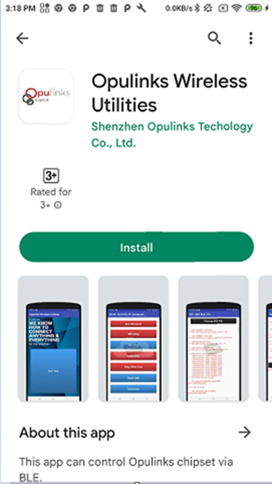

### Install iOS APP

* Search Opulinks wireless Utilities in APP Store
* Click  for installing OWU, as shown in Figure 2

Figure : Download OWU in APP Store

# OWU interface

## OWU interface Introduction

### Android

The interface icon presented by OWU on the Android phone desktop, as shown in the red box in Figure 3.

Figure : OWU in Android desktop

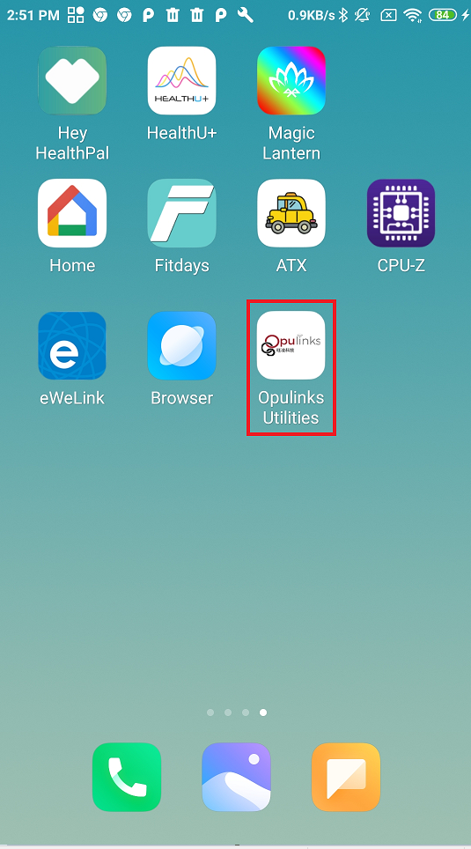

Click Opulinks Wireless Utilities APK into OWU home page, as shown in Figure 4.

Figure : OWU Home Page (Android)

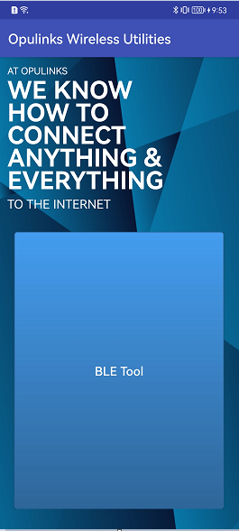

Click BLE Tool to enter the BLE scanning interface, as shown in Figure 5. The BLE scan interface will be introduced in detail in Section **3.2.1**.

Figure : BLE Scan Interface (Android)

### iOS

The interface icon presented by OWU on the desktop of the iOS mobile phone, as shown in the red box in Figure 6.

Figure : OWU in iOS desktop

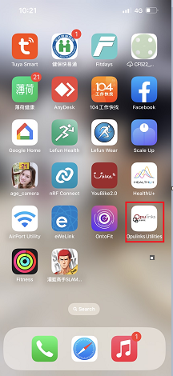

Click Opulinks Wireless Utilities APK into OWU home page, as shown in Figure 7.

Figure : OWU Home Page (iOS)

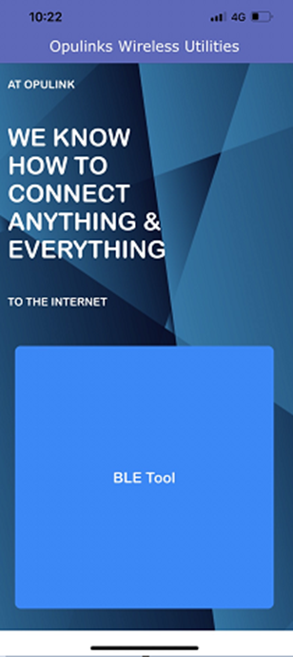

Click BLE Tool to enter the BLE scanning interface, as shown in Figure 8. The BLE scan interface will be introduced in detail in Section **3.2.2.**

Figure : BLE Scan Interface (iOS)

## BLE Scan Interface Introduction

### Android

Entering the BLE scan interface, it will automatically scan the BLE broadcasting devices in the environment. The scanning results are shown in Figure 9. OWU (Android version) provides 4 ways for users to search for scanning results:

1. **Scanning interface**: User finds the device to be connected directly on the scanning interface
2. **Keyword search field**: The user enters the Bluetooth name or BLE MAC address of the device to be connected, as shown in Figure 10
3. **Specify the Bluetooth protocol:** Click, the BLE scan interface will only display Opulink,s devices, as shown in Figure 11
4. **Historical records:** Click, will display the history of user input, as shown in Figure 12

Figure : BLE Scan Result (1)

Figure : BLE Scan Result (2)

Figure : BLE Scan Result (3)

Figure : BLE Scan Result (4)

According to the above search method, the user selects the device to be connected, and clicks to enter the OWU function interface (Android version). Section **3.3.1** introduces the OWU function interface in detail.

### iOS

Entering the BLE scan interface, it will automatically scan the BLE broadcasting devices in the environment. The scanning results are shown in Figure 13.

Figure : BLE Scan result (iOS)

OWU (iOS version) provides two ways for users to search for scan result, directly search for devices to be connected to BLE from the BLE scanning interface, as shown in Figure 14 ; or keyword search, enter keywords (Bluetooth name) in the search field, as shown in Figure 15

Figure : BLE Scan Result (iOS)

Figure : BLE Keyword Search (iOS)

According to the above search method, the user selects the device to be connected, and clicks  to enter the OWU function interface (iOS version). Section **3.3.2** introduces the OWU function interface in detail.

## OWU Function Interface Introduction

### Android

OWU (Android version) function interface has 5 function keys can be clicked, refer to Table 1and

Table : OWU Function Key table (Android version)

| No. | Function Key | Function Key Introduction |
| --- | --- | --- |
| 1 | BLE Disconnect | Disconnect BLE between mobile and device |
| 2 | Wifi Setup | Wi-Fi provision via BLE |
| 3 | BLE OTA | Upgrade the latest firmware via BLE OTA |
| 4 | Read/Write Mac | Read/write BLE or Wi-Fi MAC address |
| 5 | System Mode | System mode |
| 6 | Current Measurement | Measure current |

Figure : OWU Function Interface

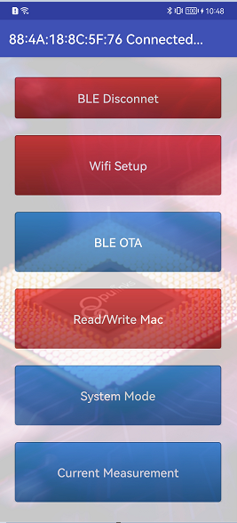

#### BLE Disconnect

Click BLE Disconnect, the APP will disconnect from the BLE-connected device, and the APP page will jump back to the BLE scanning interface, as shown in Figure 5.

#### Wifi Setup

Wifi Setup mainly allows users to configure the ssid and password of WIFI AP via BLE to realize the device networking function. Click Wifi Setup to enter the Wi-Fi scan result interface, as shown in Figure 17.

Figure : Wi-Fi Scan result

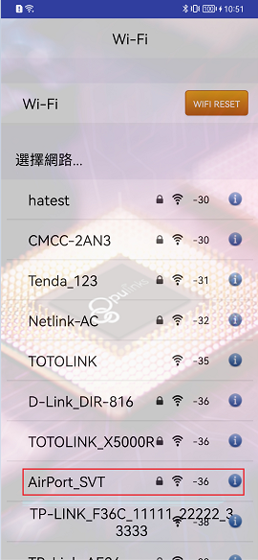

Select the target AP ssid in the scanned AP list and enter the AP password, as shown in Figure 18.

Figure : Enter Desired AP Password

After the input is complete, press the "Join" button to connect to Wi-Fi, and the device is successfully connected to the AP, as shown in Figure 19.

Figure : Connect AP Successfully

#### BLE OTA

OTA (over-the-air technology) can help products upgrade software wirelessly. OWU supports firmware update via Bluetooth. When upgrading via BLE, the user needs to download the new version of the firmware to the mobile device (such as a mobile phone, a tablet, etc.), and then transfer the new version of the software to the device to upgrade via Bluetooth connection.

Click the BLE OTA function button to enter the OTA upgrade new firmware interface, click Choose OTA File, as shown in Figure 20.

Figure : OTA Interface

After the user selects the path of the new version firmware, click its file, as shown in Figure 21.

Figure : Path of the new version firmware

After upgrading the new version of the firmware through BLE OTA successfully, it will receive [OTA_END_REQ] reason: 0, as shown in the blue box in Figure 22.

Figure : BLE OTA Successfully

#### Read/Write Mac

Users can use the Read/Write Mac function of OWU to read/write the Bluetooth and Wi-Fi MAC addresses of BLE connected devices. In the function interface (such as Figure 9), click the Read/Write Mac function button to enter Read and write MAC address function interface, as shown in Figure 23.

Figure : Read/Write MAC Address Funcion Interface

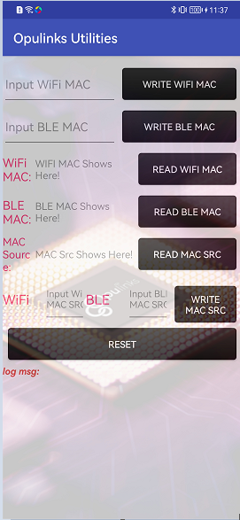

There are 7 functions for reading and writing MAC address, which are listed in Table 2.

Table : Read/Write MAC Address Function Table

| No. | Function Key | Function Key Introduction |
| --- | --- | --- |
| 1 | WRITE WIFI MAC | Write Wi-Fi MAC address into device |
| 2 | WRITE BLE MAC | Write BLE MAC address into device |
| 3 | READ WIFI MAC**錯誤! 找不到參照來源。** | Read Wi-Fi MAC address of device |
| 4 | READ BLE MAC | Read BLE MAC address of device |
| 5 | READ MAC SRC | Read the source of MAC address |
| 6 | WRITE MAC SRC | Write the source of MAC address |
| 7 | RESET | Inform device to reset |

##### WRITE WIFI MAC

The user enters the Wi-Fi MAC address to be set in the Input WiFi MAC field of the read and write MAC address function interface. After the input is completed, click the WRITE WIFI MAC function key. If the user wants to confirm whether it is correctly input to the device, click READ WIFI MAC function keys, as shown in Figure 24.

Figure : Write Wi-Fi MAC Address

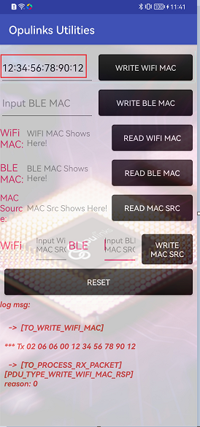

##### WRITE BLE MAC

The user enters the BLE MAC address to be set in the Input BLE MAC field of the read and write MAC address function interface. After the input is completed, click the WRITE BLE MAC function key. If you want to confirm whether it is correctly input to the device, click READ BLE MAC Function keys, as shown in Figure 25.

Figure : Write BLE MAC Address

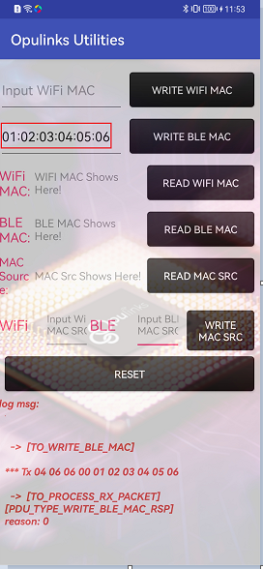

##### READ WIFI MAC

Click the READ WIFI MAC function key to read the Wi-Fi MAC address of the device.

##### READ BLE MAC

Click the READ WIFI MAC function key to read the BLE MAC address of the device.

##### READ MAC SRC

OPL series products are two sources of Wi-Fi and BLE MAC addresses of the device that flash and OTP, click the READ MAC SRC function key, and the MAC Source column shows where the current MAC address of the device is read from, as shown in Figure 26.

Figure : Read MAC Src



##### WRITE MAC SRC

Enter the source of the MAC address in the Input WiFi MAC SRC field and the Input BLE MAC SRC field. 0 means that the source is OTP, and 1 means that the source is flash. After the input is complete, click the WRITE MAC SRC function button, and you can click the READ MAC SRC function key to confirm correctly.

Figure : Write MAC Address Src

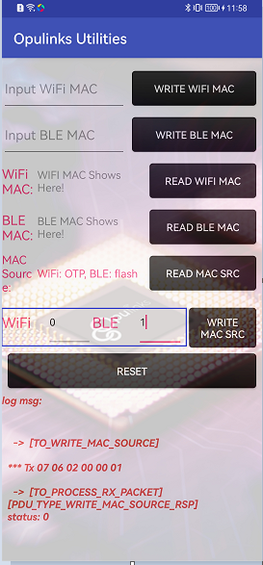

##### RESET

If the user finishes setting the MAC address, click the RESET function button to restart the device.

Note: We recommend to apply “RESET” to avoid unexpected phenomena of the equipment.

#### System Mode

The user clicks the System Mode function key on the OWU function interface to enter the system mode function interface, as shown in Figure 28.

Figure : System Mode

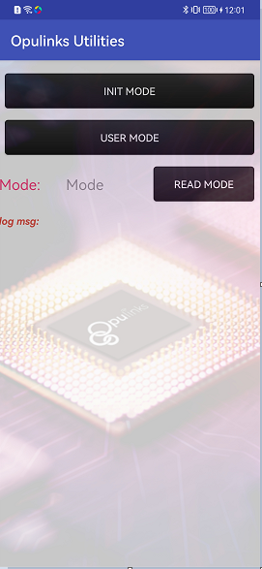

There are two function keys in System Mode:

1. **INIT MODE**: the device is set to initialization mode, as shown in Figure 29
2. **USER MODE**: the device is set to user mode, as shown in **錯誤! 找不到參照來源。**

Figure : Init Mode

Figure : User mode

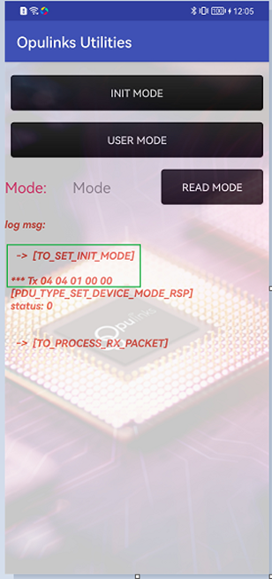

#### Current Measurement

OPL1000 series/OPL2500 chips provide three configurable sleep modes as follows:

1. Smart Sleep
2. Timer Sleep
3. Deep Sleep

Click Current Measurement on the OWU function interface (Figure 16) to enter the current measurement interface, as shown in Figure 31. Users can select a sleep mode and setup the parameters according to the corresponding sleep mode.

Figure : Current measurement mode

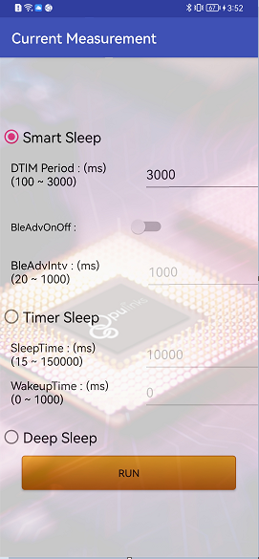

Note: To perform current measurement function, firmware QuickDev example “qd_app” built with “OPL_DATA_CURRENT_MEASURE_ENABLED” defined as “1” should be applied.

The three sleep modes will be described in detail below

##### Smart Sleep

In Smart Sleep mode, the Wi-Fi system itself will automatically adjust the receiving length of the interval between two DTIM Beacons, turn off or turn on the Wi-Fi module circuit to save power. It is realized by the system clock module to wake up automatically before the next Beacon arrives when the time is about to arrive. While sleeping, it can maintain the Wi-Fi connection with the router, and receive interactive information from the mobile phone or server through the router.

Click Smart Sleep on the current measurement interface, as shown in Figure 32. The parameters that can be configured are as follows:

1. DTIM Period: Skip the DTIM function, the setting range is 100 to 3000 milliseconds, and the default value is 3000 milliseconds
2. BleAdvOnOff: Enable or disable Bluetooth broadcasting
3. BleAdvIntv: If the user chooses to turn on the Bluetooth advertisement, the Bluetooth advertise interval should be set. The setting range is 20 milliseconds to 1000 milliseconds, and the default value is 1000 milliseconds

After the user configures the parameters, make sure the power monitor equipment connected well, then click the Run function button below to execute Smart Sleep.

Figure ：Smart Sleep

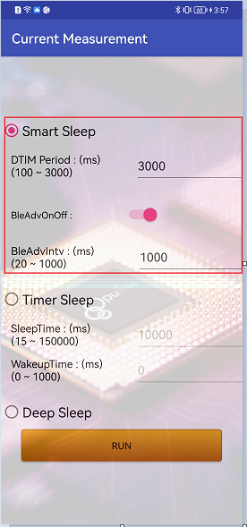

Note: If the user wants to enter the Smart Sleep mode to measure current without turning on the Bluetooth advertisement, the Devkit must be connected to Wi-Fi first, otherwise it will not work, as shown in Figure 33.

Figure ：Cannot execute Smart Sleep mode without Wi-Fi connection and BLE advertisement

##### Timer Sleep

Before entering Timer Sleep mode, the device will disconnect Wi-Fi connections and BLE connections and enter Idle state (without Wi-Fi and BLE communication operations). Only the system clock module is still working to wake up whole system.

Click Timer Sleep on the Current Measurement interface, as shown in Figure 34, and the parameters that can be configured are as follows:

**SleepTime**：Devkit sleep time, ranging from 15 milliseconds to 150000 milliseconds, the default value is 10000 milliseconds.

**WakeupTime：**Devkit awake time, the range is 0 milliseconds to 1000 milliseconds, the default value is 0 milliseconds.

For example, if the user configures SleepTime=10000 and WakeupTime=0, as shown in Figure 34, Devkit will go to sleep for 10000 milliseconds and then wake up. After wake up enter sleep mode immediately. The sleep/wake up scenario will be repeated infinitely.

After the user configures the parameters, make sure the power monitor equipment connected well, then click the Run function button below to execute Timer Sleep.

Figure ：Timer Sleep

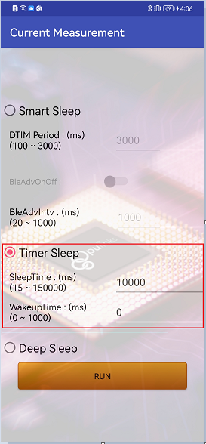

##### Deep Sleep

Before entering Deep Sleep mode, the device will disconnect Wi-Fi connection and BLE connections and enter Idle state (without Wi-Fi and BLE communication operations). the system clock module will be turned off in Deep Sleep mode.

The user selects Deep Sleep and make sure the power monitor equipment connected well, then clicks the Run function button below to execute Deep Sleep, as shown in Figure 35.

Figure ：Deep Sleep

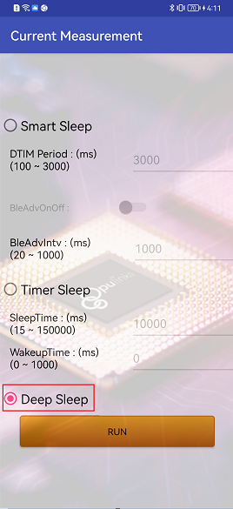

Note: If the user executes the sleep mode, the BLE connection with App will be disconnected and App will jump to back to main interface (Figure 4). To exit the current measurement, the device should be reset. After reset, user can connect to the device with App again.

### iOS

There are four function keys in OWU (iOS version) function interface refer to Table 3 and Figure 36.

Table : OWU Function Key Table (iOS Version)

| No. | Function Key | Function Key Introduction |
| --- | --- | --- |
| 1 | **錯誤! 找不到參照來源。** | Disconnect BLE between mobile and device |
| 2 | **錯誤! 找不到參照來源。** | Wi-Fi provision via BLE |
| 3 | **錯誤! 找不到參照來源。** | Upgrade the latest firmware via BLE OTA |
| 4 | **錯誤! 找不到參照來源。** | Read MAC address of the device |

Figure : OWU Function Interface (iOS)

#### BLE Disconnect

Click BLE Disconnect, the APP will disconnect from the BLE-connected device, and the APP page will jump back to the BLE scanning interface, as shown in Figure 13.

#### WiFi Setup

Wifi Setup mainly allows users to configure the ssid and password of WIFI AP via BLE to realize the device networking function. Click Wifi Setup to enter the Wi-Fi scan result interface, as shown in Figure 37.

Figure : AP list

Select the target AP in the scanned AP list and enter the AP password, as shown in Figure 38.

Figure ：AP Password Input

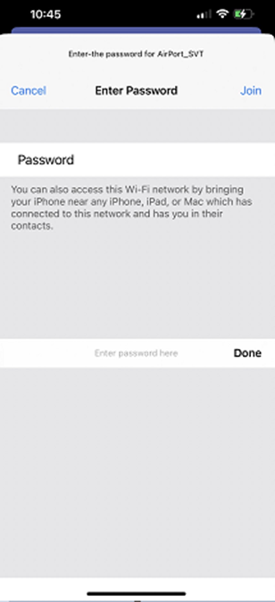

After entering the correct password, click Join to start connecting to the AP. After connecting to the AP successfully, as shown in Figure 39.

Figure ：Connect AP Successfully

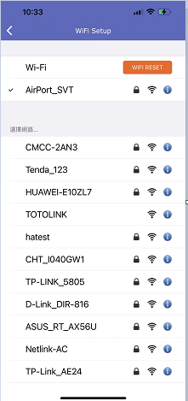

#### BLE OTA

OTA (over-the-air technology) can help products upgrade software wirelessly. OWU supports firmware update via Bluetooth. When upgrading via BLE, the user needs to download the new version of the firmware to the mobile device (such as a mobile phone, a tablet, etc.), and then transfer the new version of the software to the device to upgrade via Bluetooth connection.

Click the BLE OTA function button to enter the OTA upgrade new firmware interface, click Choose OTA File, as shown in Figure 40.

Figure ：OTA Interface (iOS)

After the user selects the path of the new version firmware, click its file, as shown in Figure 41.

Figure ：Path of the new version firmware (iOS)

After upgrading the new version of the firmware through BLE OTA successfully, it will receive [OTA_END_REQ] reason: 0, as shown in the blue box in Figure 42.

Figure ：OTA Successfully

#### Read MAC

Click the READ WIFI MAC function key to read the Wi-Fi MAC address of the device; click READ BLE MAC function key to read the BLE MAC address of the device, as shown in Figure 43.

Figure ：Read MAC Address

CONTACT

[sales@Opulinks.com](mailto:sales@Opulinks.com)